- Project Proposal
Background of the Application and Business
Business Context
The application is intended for modern, fit, jammed, and less-managed fitness centers, offering smart scheduling and access control functionality to simplify the gym experience for the user as well as staff.
Business Process Improvement
- Streamline opening of the gym at all times of the day
- Minimize wait time at the equipment
- Enhance member's satisfaction based on recommendation
- Improve security control access
- Offer key data to support and inform business decisions
Products and Services
- Gym Access: Secure 24/7 entry through biometric authentication
- Equipment Use: Strength training and cardio machines
- Personal Training: One on one sessions by certified trainers
- Nutritional Counseling: Diet plans designed according to needs of the individual
Features Overview
- User Sign-up and Profile Management
- Biometric Access Control
- Gym Slot Booking System
- Customized Workout Suggestions
- Gym Time Occupancy in Real-time

Sitemap
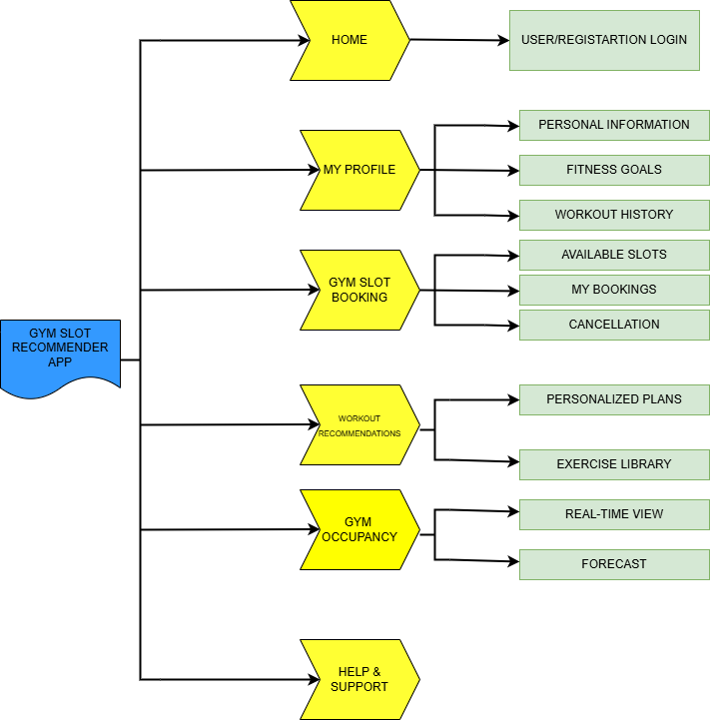

- Requirements Analysis

Business Objectives

- Increase utilization of the gym at off-peak hours by 30%
- Improve the member retention rate by 25% through personalization
- Reduce workload for the administrators in access and time allocation to the gym by 50%
User Requirements
- User Registration and Profile Management
- User has to self-register himself/herself and configure his/her profile to access the feature-rich implementation of the app.
- Biometric Access Control
- The gym member should enroll for the fingerprint access to unlock the secured facilities in the gym.
- Gym Slot Booking System
- This would help a member to avail the slots available in the gym and reserve slots as early as possible so that some equipment which they want to use during their workout is ready when they are working out.
- Personalized Workout
- A member should be given suggestions of workout sessions from the gym as per their workout goals, according to the options of available equipment. This will allow the member to be powered into an effective workout journey.
- Real-time Monitoring of the Gym Occupancy
- Since the staff will now record actual use at every gym, the management of the gym will be in a position to monitor their resources and thus offer quality service for members.
Functional Requirements
- User Sign-up/Profile Management
- The system shall allow users to sign up by either using email or social media integration.
- The application shall ensure that a user can edit personal details, fitness goals, and preference.
- The system must protect the user data within the protection of the data in accordance with the data protection regulations.

- Biometric Access Control
- The system shall support fingerprint registration and verification
- Access logs must be maintained for security purposes
- The system should have a backup access method (e.g., PIN) in case of biometric failure
- Gym Slot Booking System
- The system shall display available slots based on real-time gym occupancy and user preferences
- Users must be able to book, modify, or cancel slots up to 24 hours in advance
- The system should send reminders to users about their upcoming bookings
- Personalized Workout Recommendations
- The system shall generate workout plans based on user goals, fitness level, and available equipment
- Recommendations must be updated based on user feedback and progress
- The system should provide a library of exercise demonstrations and instructions
- Real-time Gym Occupancy Tracking
- The system shall update gym occupancy data in real-time based on check-ins and check-outs
- Occupancy data must be visualized in an easy-to-understand format for both staff and members
- The system should provide occupancy forecasts based on historical data and current bookings

3. Sprint Planning
Sprint 1 (Foundation and User Interface Basics) | Deadline (27.09.2024)
Project Setup and Version Control
Database Schema Design
User Interface Wireframing (UI/UX Design)
Sprint 2 (User Authentication and Backend Integration) | Deadline (04.10.2024)
User Authentication Implementation
Firebase Backend Setup
Main App UI Design (UI/UX Design)
Sprint 3 (Booking System and Biometric Access) | Deadline (11.10.2024)
Gym slot booking system backend
Biometric Access Integration
Booking and Access UI Implementation
Sprint 4 (Personalization and Real Time Features) | Deadline (18.10.2024)
Workout Recommendation System
Gym Occupancy Tracking
Personalization and Occupancy UI
Sprint 5 (Integration, Testing and Refinement) | Deadline (25.10.2024)
System Integration and Testing
Analytics and Reporting Features
Final UI/UX Refinement

